SOP for Soldering

Embedded Systems Lab (ESL)

Review the following information and watch the instructional video:

[How and WHY to Solder Correctly: http://www.youtube.com/watch?v=I_NU2ruzyc4](http://www.youtube.com/watch?v=I_NU2ruzyc4).

You are welcome to use soldering resources outside of this lab. If you choose to use one of these outside entities you must comply with all of their rules and arrange for times when you can solder with them.

1. Process: Using the soldering iron.

2. Hazard: Burns, hot melted rosin core/flux splash.

3. Personal Protective Equipment: Safety glasses or goggles.

4. Engineering Controls: Make sure iron temperature does not exceed 650 °F or 750 °F for thick wire soldering.

- Allowing the temperature to exceed this could allow the solder to boil causing hot liquid metal to splash.

5. Special Handling Procedures:

Setting up the iron:



• Turn on the main switch to the iron. Set the temperature to 650 °F, or 750 °F for thick wire soldering.

• Apply some de-ionized water from the wash bottle to dampen the sponge in the stand. **It should be damp, not dripping wet.**

• Wait a few minutes for the soldering iron to warm up (indicated by the flashing LED).

Using the equipment:

• **Never touch the element or tip of the soldering iron. They are very hot and will give you a nasty burn.**

• **Always return the soldering iron to its stand when not in use. Never put the iron down on your workbench or equipment, even for a moment! The hot element may accidentally burn someone or damage the bench or equipment.**

• Check if it is ready by trying to melt a little solder on the tip. If the iron tip looks black/burned and does not melt solder follow “repair” steps below.

• The smoke formed as you melt solder is mostly from the flux and quite irritating. **Use goggles to protect your eyes from irritation and optionally a fan to direct the smoke away from you.**   
• Melt some solder on the tip of the iron and wipe once or twice on sponge to remove excess solder. This 'tinning' will help the heat to flow from the iron's tip to the joint. This is necessary when you first turn on the iron and occasionally while soldering if you need to wipe the tip clean on the sponge.

• Do not excessively wipe the iron on the sponge, this will remove all solder from it and will need to be re-tinned.

• Hold the soldering iron like a pen, near the base of the handle. Imagine you are going to write your name! **DO NOT touch the hot element or tip.**

Applying the solder:

• Touch the soldering iron tip onto the joint to be made. Make sure it touches both the component lead and the pad. • • • Hold the tip there for a few seconds and...

• Feed a little solder onto the joint. It should flow smoothly onto the lead and pad to form a volcano shape as shown in the diagram. Apply the solder to the joint, not the iron.

• **Remove the solder, then the iron**, while keeping the joint still. Allow the joint a few seconds to cool before you move the circuit board.

• Remember to return the iron to the stand.

• Inspect the joint closely. It should look shiny and have a 'volcano' shape. If not, you will need to reheat it and feed in a little more solder. This time ensure that both the lead and pad are heated fully before applying solder.

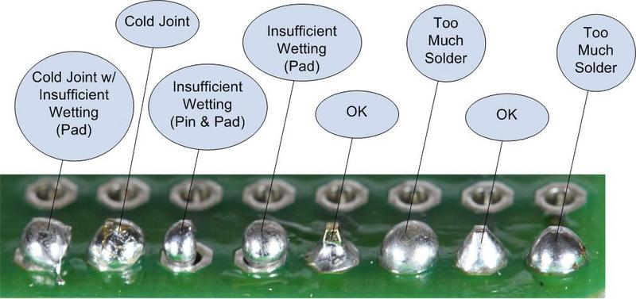

Too much solder/Re-soldering components:

• Sometimes we apply too much solder to a connection causing a short between the leads. Other times we may realize that we soldered the wrong components together. Both can be fixed with a desoldering pump.



• The pump is effectively a spring loaded vacuum; to use it, load the spring on the desoldering pump by pressing it down. Hold the pump in one hand and use your other hand to apply the soldering iron to the solder you wish to remove. • • • Hold the tip there for a few seconds until the solder turns liquid and...

• Quickly remove the iron and apply the tip of the desoldering pump over the still liquid solder. Press the release button and the pump and the solder will be pulled away from the joint.

• **It is important to have safety goggles on while doing this, you are causing hot solder to fly up inside the pump.**

• The transition from soldering iron to desoldering pump must be quick, however take care to not be reckless in your movement.

• Sometimes applying more solder, helps remove a smaller persistent amount of solder. This is because a bigger glob of solder has a larger mass to be sucked up by the soldering pump.

When done soldering:

• “Tin” the iron tip and add a glob of solder to the tip. This will protect the iron tip from oxidizing if it is turned on and left standing for a long time by the next user.

• Make sure to return the iron to the stand.

• Switch off the power to the iron after use.

If repairs are necessary (if dark/burned looking tip, iron tip does not melt solder, temperature display shows incorrect temperature):

• If the temperature display is incorrect, turn the temperature knob and reset to 650 °F.

• If the iron tip looks black or burned (oxidized) it must be re-tinned; following tinning process.

• If the solder will not melt at all on the tip, firmly “wipe” the iron tip on the brass sponge. (This looks like a dish steel wool in a container.)

• Immediately after wiping the iron tip apply solder then continue with the tinning process.

• If this still does not fix the problem inform the TA.

6. Accident Procedures:

a. Use an available first aid kit or burn kit.

b. Seek medical help from Campus Health Center (951-827-3031), or Riverside Community Hospital (951-788-300).

c. Call 911 or if using Cell Phone 951-827-5222 for emergency assistance.

7. Prior Approval: You may only use this equipment after:

a. watching the instructional video

b. reading this SOP (signature and date)

c. you are wearing the proper personal protective equipment

d. notifying an authorized person that you will be working with the soldering iron, and making sure they will be available to supervise if needed.

*Sign signature sheet.